33.33: a)
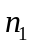 as it did in part (a).
c) For reflection, 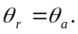 These angles are still equal if 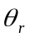 becomes the incident angle; reflected rays are also reversible.

